

PRT564
DATA ANALYTICS AND VISUALISATION

ASSESSMENT 02

GROUP PRESENTATION:
NORTHERN TERRITORY CRIME ANALYSIS & PREDICTION

Submitted by: Group 1 Lecturer: Dr. Yakub Sebastian

Thi Xuan Thanh Tran - S389244
Ngoc Anh Nguyen - S386805
Bipana Tripathee - S388875
Le Nhat Minh Tran - S390789

April 2026
￼￼
Table of Contents
1. Introduction 3
2. Organization context and problem definition 3
2.1. Stakeholder Context 3
2.2. Problem Definition 3
3. Data Pipeline 4
3.1. Heterogeneous Data Sources 4
3.2. Data Cleaning & Integration 5
4. Exploratory Data Analysis 7
4.1. Dataset Overview 7
4.2. RQ1: What is the month with the highest crime rate? 8
4.3. Assault Analysis 10
4.3.1. Regional Assault Rates 10
4.3.2. Modelling Insights from EDA 11
5. Regression Analysis 13
5.1. Regression Dataset 13
5.2. Feature Engineering 14
5.3. Feature Variant Comparison 15
5.4. Model Selection and Hyperparameter Tuning 16
5.5. Model Evaluation 17
5.6. Regression Assumption Checks 17
5.7. Statistical Testing 18
5.7.1. Paired t-Test: Model Comparison 18
5.7.2. Shapiro-Wilk Test: Residual Normality 19
5.8. Feature Importance 19
5.9. Monthly predictions for each region 20
6. Conclusion 21
6.1. Answer to RQ1 21
6.2. Answer to RQ2 21
7. Strengths and Limitations 22
7.1. Strength 22
7.2. Limitations 22
References 23

Table of Figures

Figure 1: Population by region 2024 vs 2025 6
Figure 2: Offences by category 2024 vs 2025 6
Figure 3: Proportion of offences involving alcohol and DV 7
Figure 4: Total offences by month 7
Figure 5: Offences per 100,000 population by month 8
Figure 6: Monthly Crime Trend 2024 vs 2025 8
Figure 7: Month x offence category heatmap 9
Figure 8: Raw counts and avg quarterly rate per 100k by region, 2024 vs 2025 9
Figure 9: Average monthly assault by region across 2024-2025 10
Figure 10: Assault Offences Distribution 10
Figure 11: Quarterly Total PAC by region 2024-2025 11
Figure 12: PAC vs Assault offences scatter, colour-coded by region 11
Figure 13: Correlation Heatmap - Assault Predictors 12
Figure 14: Test RMSE for V1-V4 14
Figure 15:CV RMSE vs alpha for Ridge and Lasso 15
Figure 16: Test RMSE and CV RMSE across three models 16
Figure 17: Linear Regression Assumption Checks 17
Figure 18: Paired t-Test: Model Comparison 18
Figure 19: Feature Coefficients: Ridge vs Lasso 19
Figure 20: Predicted vs actual assault rate per region summary (2025) 20
Figure 21:Predicted vs Actual Assault Rate by Region (2025) 21

- Introduction
The Northern Territory records Australia's highest imprisonment rate and among the highest assault rates nationally. This project addresses the NT Police, Fire and Emergency Services' (PFES) need for predictive capability to anticipate alcohol-related crime risks, crime hotspots and allocate resources more effectively.

Using three heterogeneous government datasets: NT crime statistics, regional population demographics, and wholesale alcohol supply data, we built a regression pipeline to answer two research questions:
• RQ1: What is the month with the highest crime rate?
• RQ2: Predict monthly assault rates for each NT region using past crime data, population characteristics, and alcohol supply volumes.

- Organization context and problem definition
  - Stakeholder Context
The Northern Territory Police, Fire and Emergency Services (PFES) is the primary agency responsible for crime prevention, incident response, and law-and-order policy advice to the NT Government. Despite the NT having a population of approximately 264,000, it records Australia's highest imprisonment rate at 1,419 prisoners per 100,000 adults (ABS, 2025) and the highest rate of assault nationally.
Two key stakeholder groups were identified:
• PFES Operations: responsible for collecting crime data, enforcing laws, and implementing crime-reduction policies. Require forecasts of crime hotspots to optimise patrol resource deployment.
• Local communities and remote residents: directly affected by crime, particularly in high-risk regions. Seek safer environments through targeted prevention programmes.
  - Problem Definition
Current PFES reporting provides descriptive summaries of historical crime but lacks predictive capability. Specifically:
• No mechanism exists to anticipate which regions will experience elevated assault in the coming month.
• Resource allocation relies on historical averages rather than data-driven forecasts.
• The relationship between alcohol supply volumes, population characteristics, and crime rates has not been formally modelled.
This project integrates crime, population, and alcohol supply data to develop a predictive regression model that enables PFES to deploy resources to areas where assaults are expected to rise, helping prevent crime before it occurs.

- Data Pipeline
  - Heterogeneous Data Sources
Three datasets from distinct NT Government sources were integrated, demonstrating the heterogeneous nature of the analysis:
Table 1: Data sources
Datasets | Publisher | Date published | URL | File format | Rows | Columns
NT Crime Statistics Dec 2025 | Department of the Attorney-General and Justice | 17 February 2026 | https://data.nt.gov.au/dataset/current-nt-crime-statistics-december-2025 | CSV | 7884 | 10
NT Government Regions 1986 to 2025 | Department of Health | 07 March 2024 | https://data.nt.gov.au/dataset/nt-government-regions-1986-2025 | XLSX | 17280 | 7
Wholesale Alcohol Supply by Quarter, 2023 | Department of Tourism and Hospitality | 13 November 2025 | https://data.nt.gov.au/dataset/wholesale-alcohol-supply-by-quarter-2023 | XLSX | 28 | 12
Wholesale Alcohol Supply by Quarter, 2024 |  |  | https://data.nt.gov.au/dataset/wholesale-alcohol-supply-by-quarter-2024 |  | 28
Wholesale Alcohol Supply by Quarter, 2025 |  |  | https://data.nt.gov.au/dataset/wholesale-alcohol-supply-by-quarter-2025 |  | 14
Justification for each source:
• Crime statistics: primary dataset containing monthly offence counts by region, type, alcohol involvement, and DV involvement - the foundation of both research questions.
• Population data: essential for computing per-capita crime rates that allow fair comparison across regions with vastly different populations (Greater Darwin: 155,832 versus Barkly: 7,471). Also provides demographic features (age groups, Aboriginal status, sex) for regression predictors.
• Alcohol supply: justified by the established criminological link between alcohol availability and violent crime. Wholesale PAC (Pure Alcohol Content in litres) is the best available proxy for actual alcohol consumption in each region.
  - Data Cleaning & Integration
The complete pipeline runs in 01_data_preprocessing.py and produces nt_crime_merged.csv (3,202 rows x 47 columns) as the single analysis-ready file fed into both EDA and regression.
Step 1: Crime Data Cleaning
• Drop Unknown region: 8 offences with no geographic anchor removed.
• Drop Year 2023: only December 2023 exists in raw data (1 of 12 months). Including one month as a full year introduces severe temporal bias. Analysis restricted to 2024-2025 (24 complete months).
• Binary encoding: Alcohol involvement and DV involvement encoded as 0/1. The dash '-' (not applicable for non-assault offences) encoded as 0.
• Quarter derived from Month number for joining with quarterly alcohol data.
Step 2: Region Remapping
Crime data uses 7 NT Police regions; population data uses 6 NT Government statistical regions. A naive mapping would assign the same Greater Darwin population (155,832) to both Darwin and Palmerston, severely distorting per-capita rates. All crime rows remapped in two stages:
- Stage 1: Direct mapping:
Darwin + Palmerston Greater Darwin
Alice Springs Central Australia
Katherine Big Rivers
Nhulunbuy East Arnhem
Tennant Creek Barkly
NT Balance Top End
- Stage 2 - SA2-level mapping: NT Balance rows are further disaggregated via the Statistical Area 2 column. For example:
SA2 = 'Barkly' Barkly
SA2 = 'East Arnhem' East Arnhem
SA2 = 'Howard Springs' Greater Darwin
Step 3: Population Features
Population data filtered to 2024-2025. Total_population, Aboriginal, Male/Female, and 18 age group columns aggregated to region/year level and joined as flat columns.
Step 4: Alcohol Aggregation
Files for 2023-2025 combined. Darwin and Palmerston PAC summed into Greater Darwin. Q3-Q4 2025 values (missing due to publication lag) imputed using same-region same-quarter mean from 2023-2024, justified by stable seasonal supply patterns in the NT.
Step 5: Merging Datasets
Two left joins:
Crime + Alcohol on [Year, Quarter, Region],
then + Population on [Year, Region].
Offences summed per grouping key.
Final dataset after merging:
Table 2: Final dataset after mergin
Property | Value
File | Nt_crime_merged.csv
Rows x Columns | 3,202 x 47
Coverage | 2024-2025, 24 months, 6 regions
Null values | 0

- Exploratory Data Analysis
EDA was conducted to understand the dataset characteristics and directly inform modelling decisions.
  - Dataset Overview
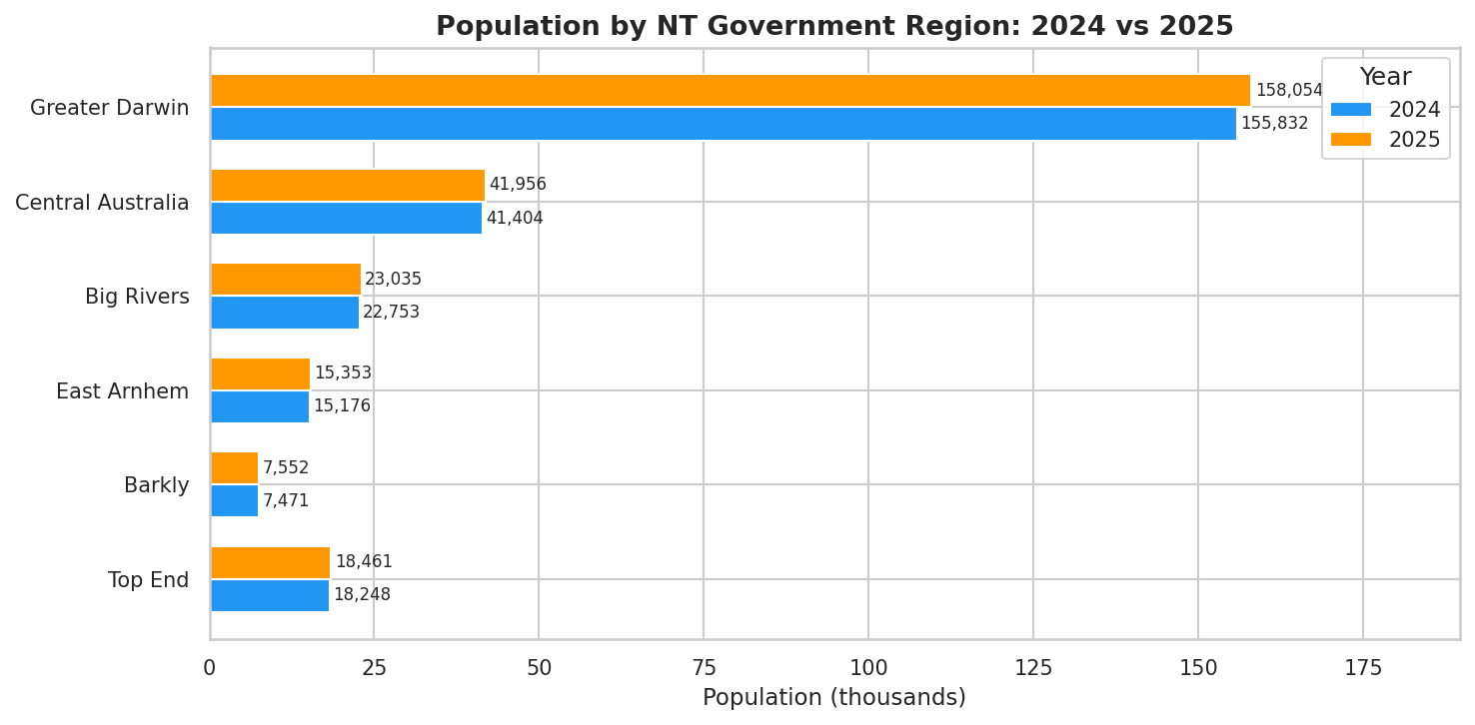
Figure 1: Population by region 2024 vs 2025
Greater Darwin has the highest population (158,054 in 2025). Barkly has the smallest population (7,552 in 2025). Justifies use of per-capita rates for fair regional comparison.
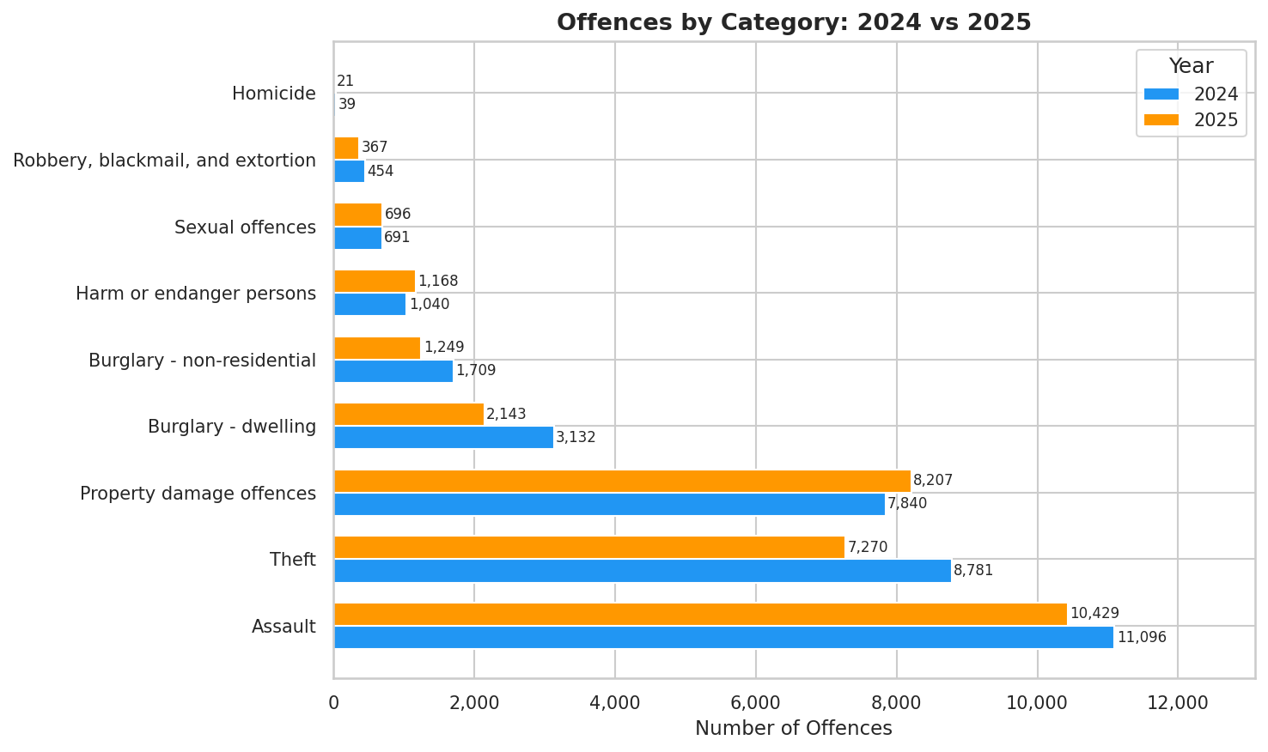
Figure 2: Offences by category 2024 vs 2025
Assault is the most common offence category in both years (11,096 in 2024; 10,429 in 2025), confirming it as the appropriate focus for RQ2.
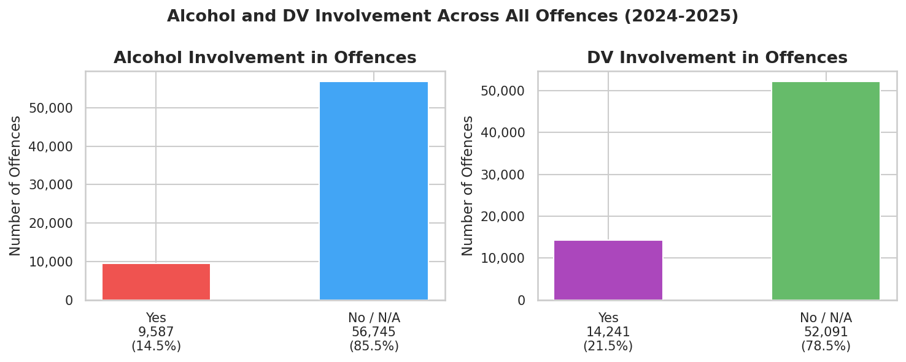
Figure 3: Proportion of offences involving alcohol and DV
There is 14.5 % of offence involve alcohol and 21.5% involve DV in 2024-2025. Both are regression predictors concentrated in specific regions and months.
  - RQ1: What is the month with the highest crime rate?
January is the peak crime month with 6,168 total offences in 2025, and it consistent across both 2024 and 2025. The pattern aligns with the NT wet season, post-Christmas gatherings, and increased alcohol consumption. Assault and theft drive the spike, while property damage is more uniform year-round.

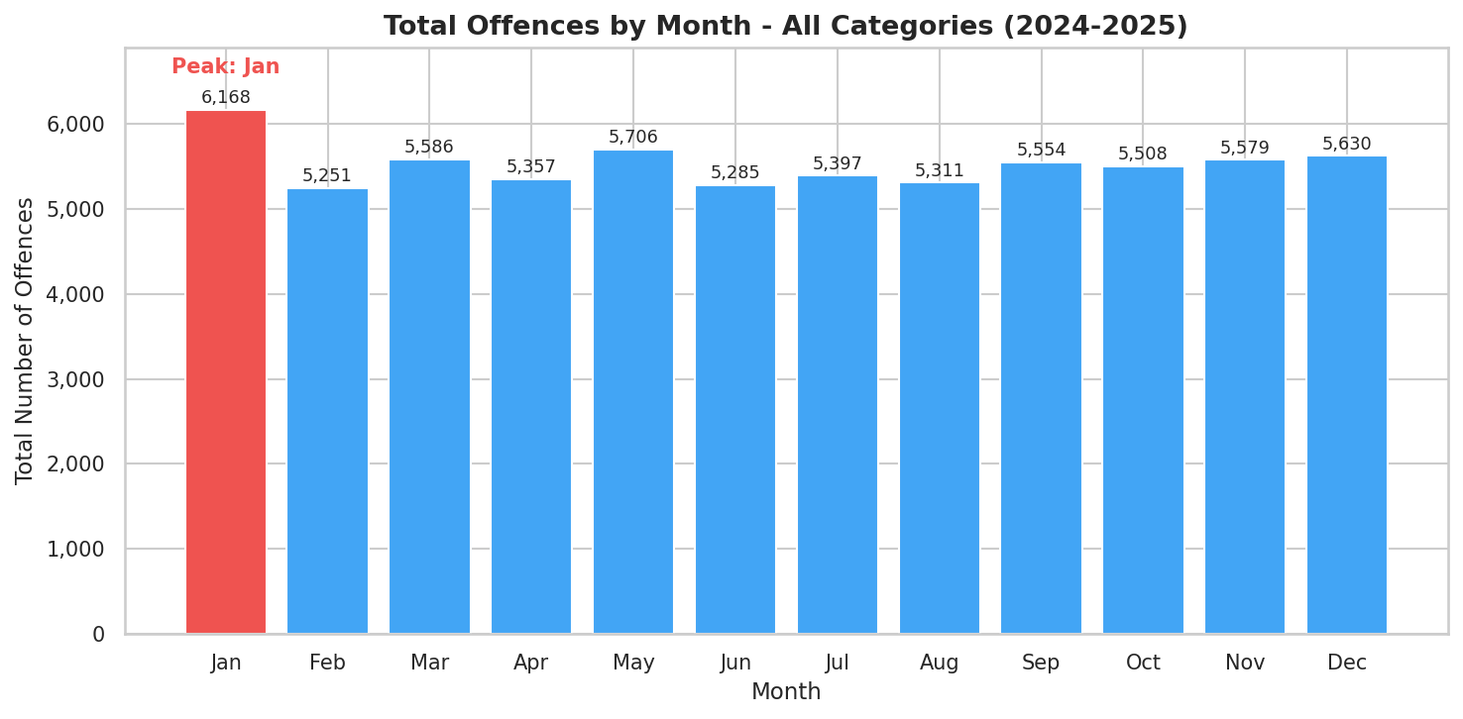
Figure 4: Total offences by month
January highlighted in red as peak. Directly answers RQ1.
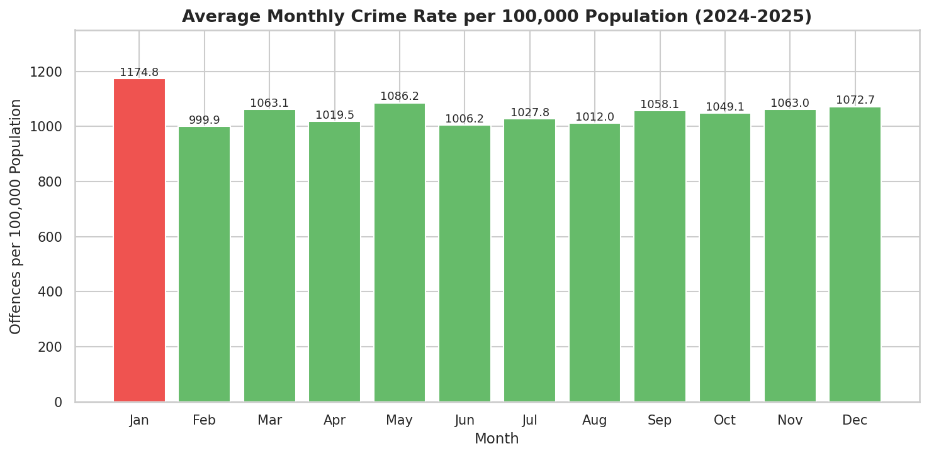
Figure 5: Offences per 100,000 population by month
January remains peak. The finding is not an artefact of population differences.

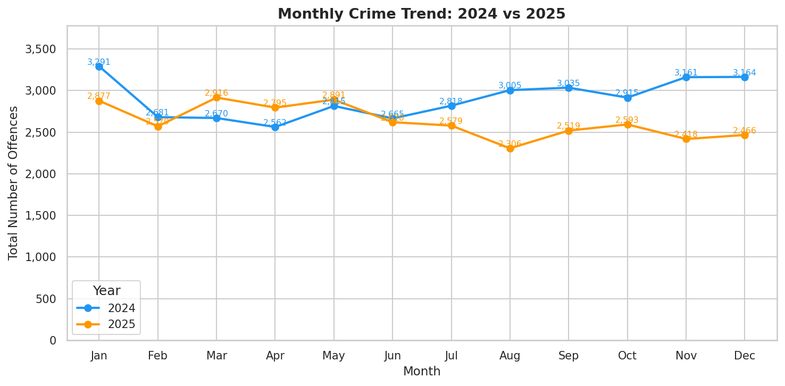
Figure 6: Monthly Crime Trend 2024 vs 2025
Both years show the same January peak, which indicates that the pattern is stable, not a one-off event.
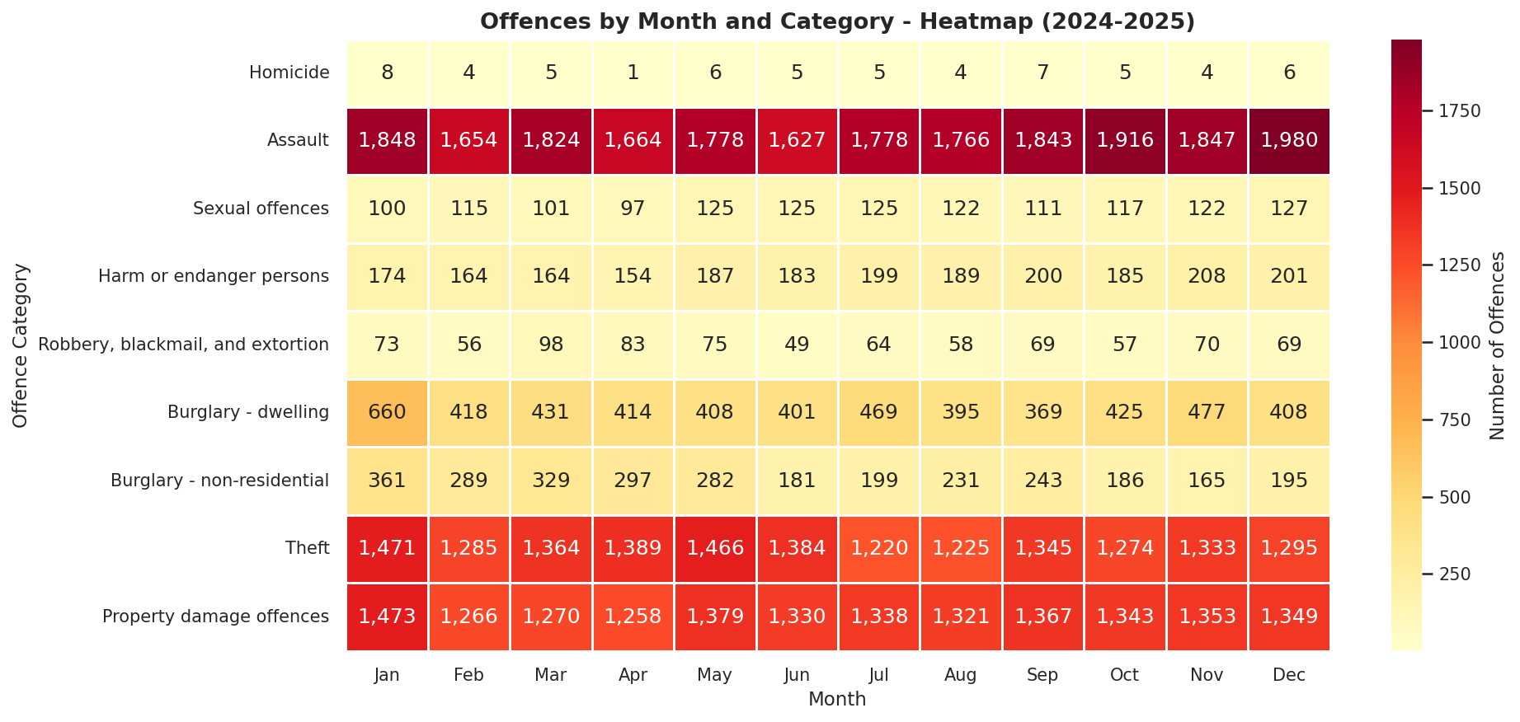
Figure 7: Month x offence category heatmap
The pattern is driven by assault and theft, which peak strongly in January. Property damage is more uniformly distributed year-round.

  - Assault Analysis
    - Regional Assault Rates
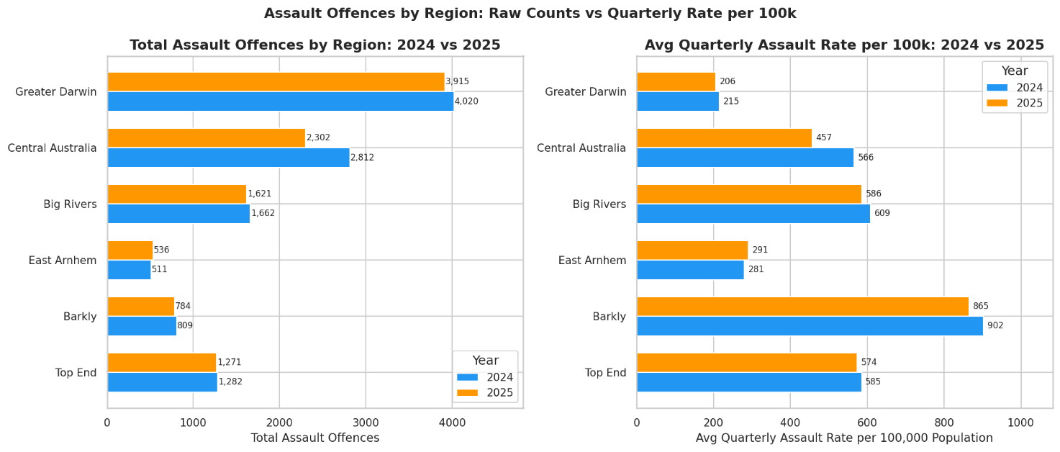
Figure 8: Raw counts and avg quarterly rate per 100k by region, 2024 vs 2025
Greater Darwin has the highest raw assault count (4,020 in 2024; 3,915 in 2025) due to its large population. However, on a per-capita basis, Barkly has the highest rate (865 per 100k in 2025) which is more than 4 times the Greater Darwin rate (206 per 100k in 2025). This demonstrates why per-capita analysis is essential for fair regional comparison.

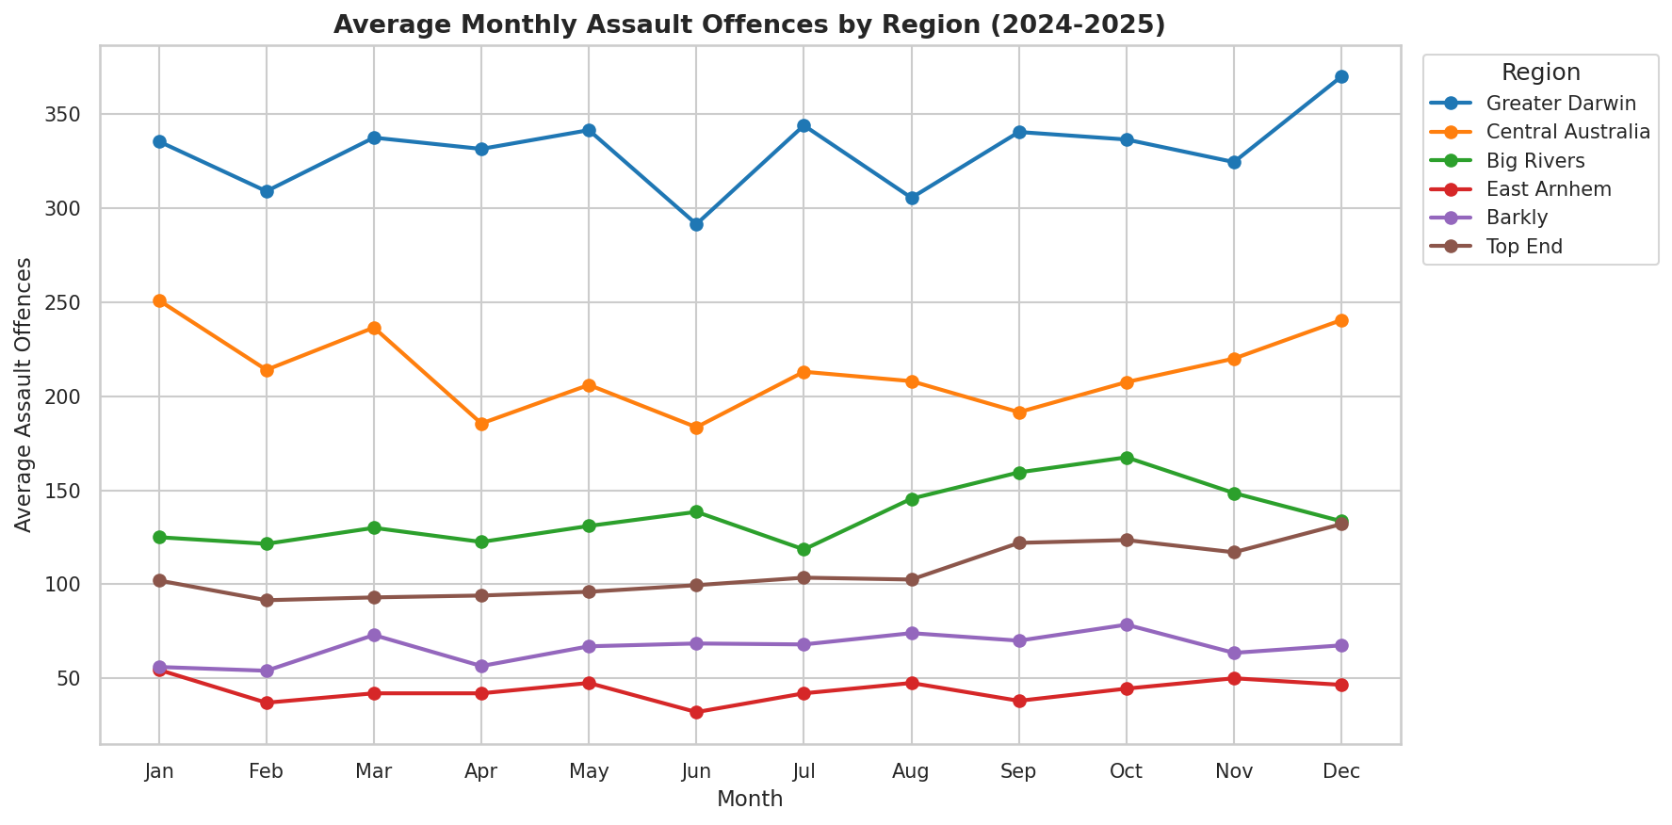
Figure 9: Average monthly assault by region across 2024-2025
Figure 9 shows that seasonal patterns differ by region: Central Australia peaks January, Greater Darwin peaks December. Most regions show elevated assault in the November - January period (Wet Season onset), motivating the inclusion of cyclic month encoding (sin/cos) to capture seasonal variation.
    - Modelling Insights from EDA
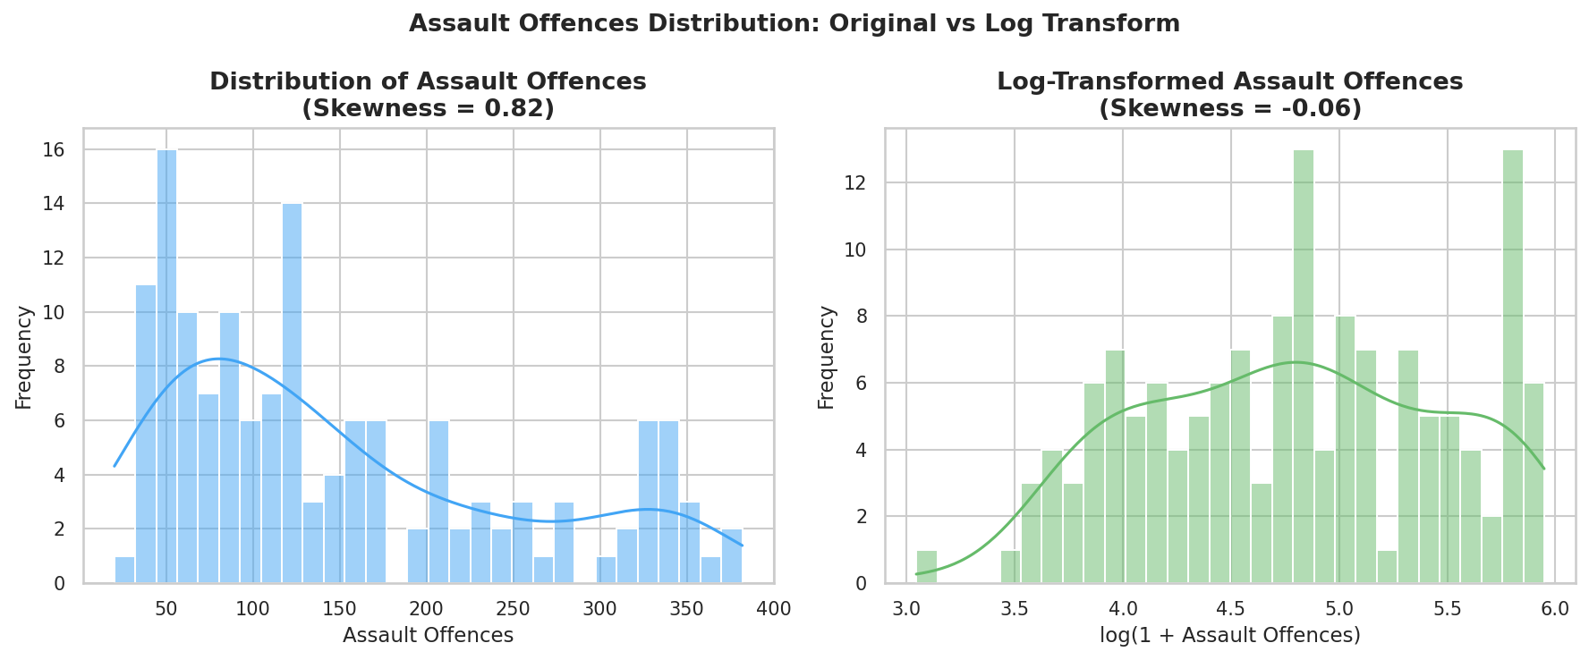
Figure 10: Assault Offences Distribution

Distribution assault rate is right-skewed (skewness = 0.82). Log transformation reduces skewness to -0.06, satisfying the near-normality assumption for linear regression. Therefore, log-transformed target log(1 + Assault_rate_100k) is used throughout the regression analysis.
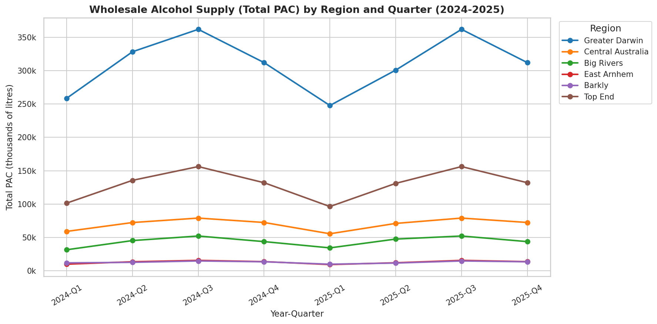
Figure 11: Quarterly Total PAC by region 2024-2025
Figure 11 shows the seasonal pattern, which higher Q2 (Dry Season) and Q4 (end-of-year). This validates PAC as a predictor with meaningful temporal variation.
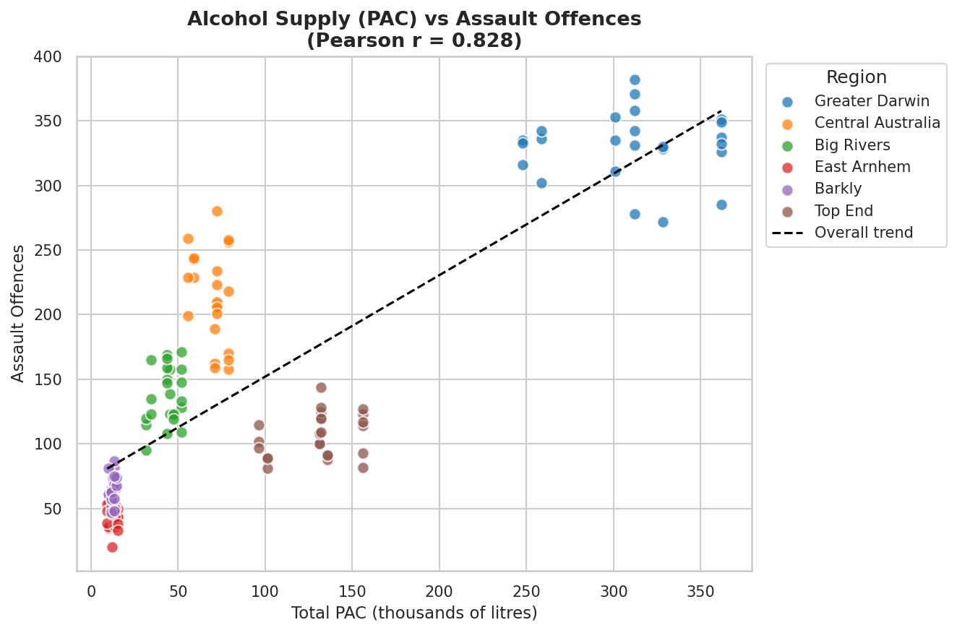
Figure 12: PAC vs Assault offences scatter, colour-coded by region
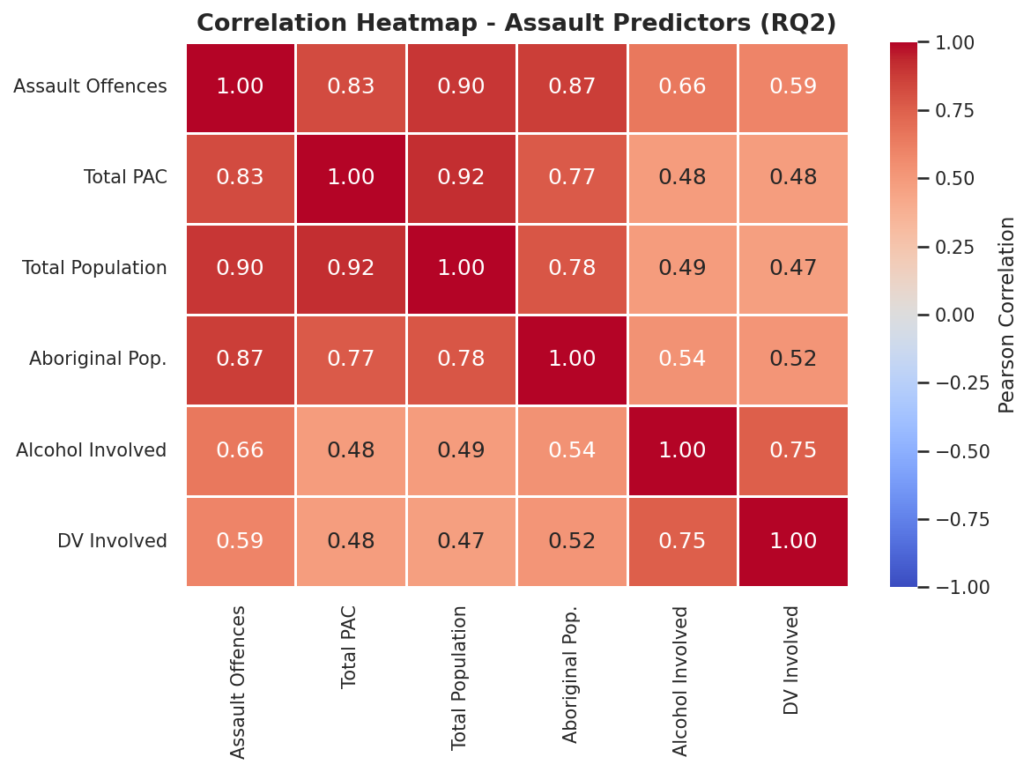
Figure 13: Correlation Heatmap - Assault Predictors
Total Population (r = 0.90) and Total PAC (r = 0.83) are strongest. High mutual correlations signal multicollinearity, which can be addressed by Ridge regularisation.
- Regression Analysis
  - Regression Dataset
The merged dataset filtered to assault offences and aggregated to one row per region per month, yielding a time series of 144 region-month observations. After removing rows with missing lag values, 126 usable observations remain including 54 training (2024) and 72 test (2025).

Table 3: Regression Dataset
Property | Value | Justification
Target variable | Log(1 + Assault_rate_100k) | Log transform reduces skewness from 0.82 to -0.06, satisfying near-normality assumption for LR.
Scaling | StandardScaler (mean =0, std =1) | Required for Ridge and Lasso so regularisation penalty is applied uniformly across all features regardless of their original scale.
Reference region | Greater Darwin (dropped from dummies) | Largest, most urbanised region; natural baseline for comparison.
  - Feature Engineering
Table 4: Feature Engineering
Feature | Justification
Sin_month, cos_month | Month is cyclic, integer encoding makes them appear 11 steps apart. Sin/cos pair encodes them as adjacent. Both sin and cos must be used together to avoid ambiguity (months 2 and 10 have the same sin value but different cos values).
Assault_rate_lag1 | Crime has temporal autocorrelation, last month's rate is the strongest predictor of this month's rate. Computed AFTER sorting by region, year, month to guarantee correct temporal order.
Assault_rate_lag3 | Captures quarterly trend and seasonal persistence in assault rates.
Alcohol_per_capita | Controls for region size. Greater Darwin has high Total PAC simply because it has more people. Per-capita isolates the alcohol supply effect.
Alcohol_involved, DV_involved | Count of alcohol-involved and DV-involved offences per region-month.
Reg_Barkly, Reg_Central Aus., Reg_East Arnhem | Captures persistent fixed regional differences not explained by other features - e.g., remoteness, service availability, policing intensity.
  - Feature Variant Comparison
Before selecting a final model, four progressively richer feature sets were tested using Linear Regression as a neutral baseline. This determines the marginal contribution of each feature group.
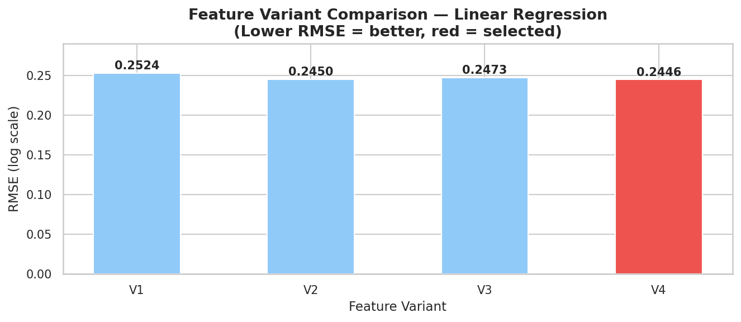
Figure 14: Test RMSE for V1-V4
Table 5: Feature Variant Comparison
Variant | Features | Test RMSE | Insight
V1: Temporal only | sin_month, cos_month, lag1, lag3 | 0.2524 | Temporal features alone achieve good performance. Lag features are highly informative
V2: + Alcohol | V1 + alcohol_per_capita | 0.2450 | Alcohol supply adds meaningful predictive value
V3: + Crime context | V2 + Alcohol_involved, DV_involved | 0.2473 | Crime context slightly overfit on this small test set.
V4: + Region dummies | V3 + region dummies | 0.2446 | Region fixed effects give lowest test RMSE.
V4 (Full feature set) was selected with the lowest test RMSE of 0.2446. This selection is further validated by cross-validation.

  - Model Selection and Hyperparameter Tuning
Table 6: Model Comparison
Model | Regularisation | Key Property | Role
Linear Regression | None | Baseline - no bias, may have high variance with correlated features | Benchmark
Ridge Regression (L2) | α × Σwᵢ² | Shrinks all coefficients toward zero but keeps all features. Robust to multicollinearity. | Primary candidate.
Lasso Regression (L1) | α × Σ|wᵢ| | Sets some coefficients to exactly zero, automatic feature selection. Useful for identifying the most important features. | Diagnostic: reveals which features matter
Hyperparameter tuning (alpha grid search via TimeSeriesSplit CV)
Alpha controls regularisation strength. TimeSeriesSplit is used because the data is a time series: training on future data to predict past data (data leakage) must be avoided.

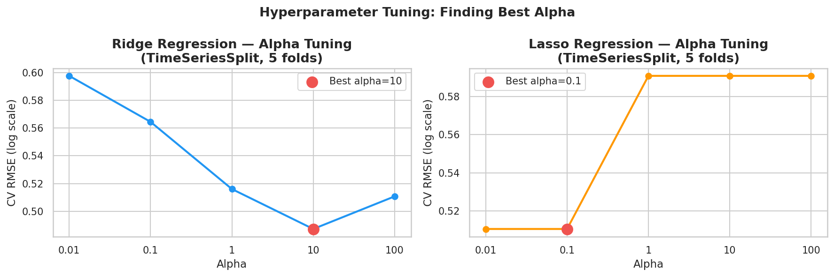
Figure 15:CV RMSE vs alpha for Ridge and Lasso
Best Ridge alpha = 10 (CV RMSE = 0.4873). Higher alpha is better for Ridge here because the feature set contains high-VIF lag features - stronger regularisation prevents them from dominating.
Best Lasso alpha = 0.1 (CV RMSE = 0.5105). Lasso converges at lower alpha because it already zeroes out most features, so additional penalty adds no benefit.

  - Model Evaluation
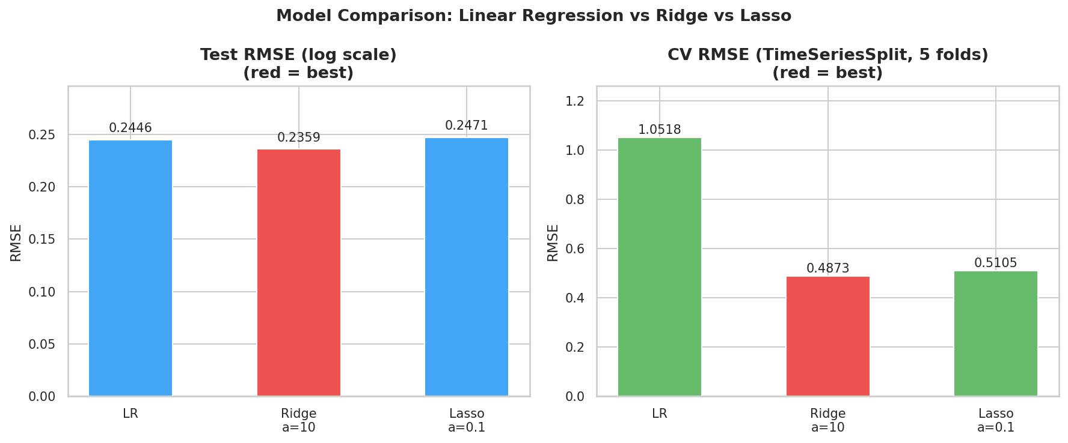
Figure 16: Test RMSE and CV RMSE across three models
Ridge Regression (alpha=10) is selected as the final model based on lowest cross-validation RMSE (0.4873), indicating the best generalisation to unseen time periods.
  - Regression Assumption Checks
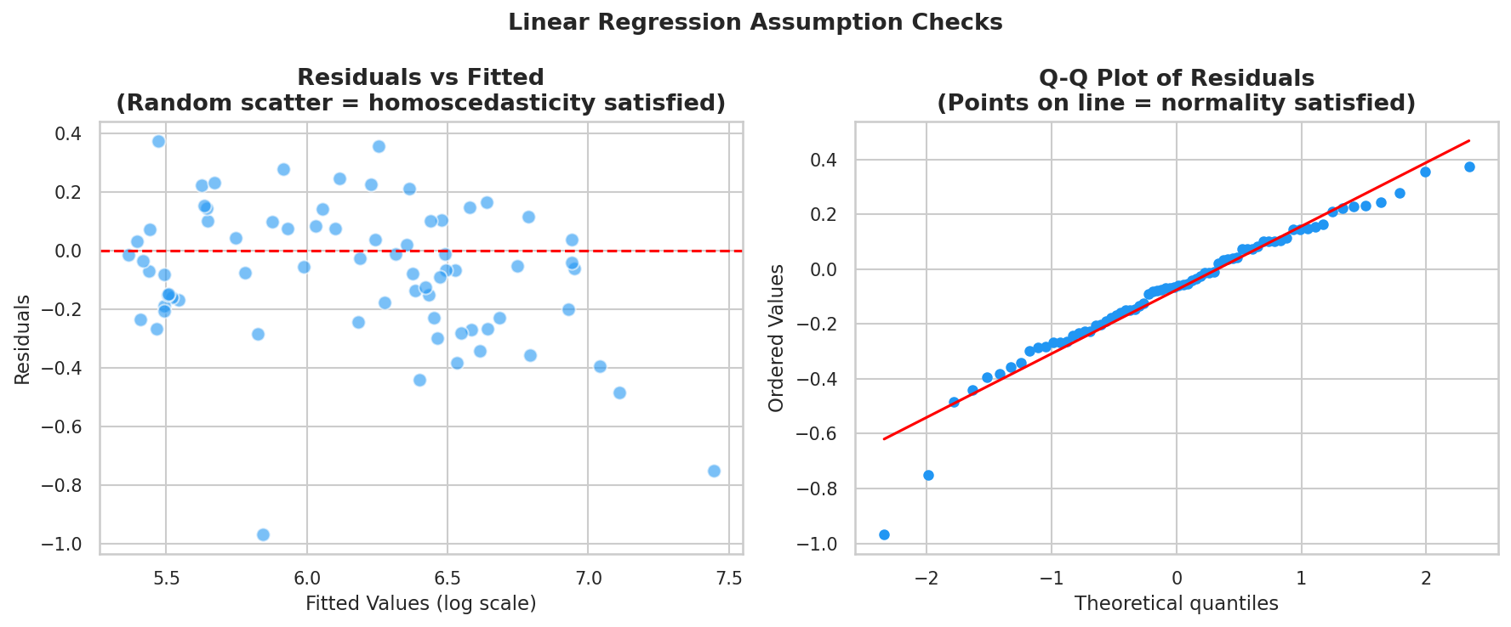
Figure 17: Linear Regression Assumption Checks

Table 7: Regression Assumption Checks
Assumption | Test | Result | Implication
Normality of residuals | Sharipo-Wilk | W=0.9520, p=0.0080 => NOT normal (p < 0.05) | W close to 1.0 indicates minor deviation. Ridge more robust to non-normality.
Homoscedasticity | Residuals vs Fitted plot | Random scatter around zero, no fan/funnel shape | Approximately satisfied
No perfect multicollinearity | VIF analysis | Lag feature VIF > 50. Demographic ratios excluded. | Ridge handles via L2 regularisation
Time series integrity | TimeSeriesSplit CV | Future data never used in training folds | No data leakage
  - Statistical Testing
    - Paired t-Test: Model Comparison
Paired t-Test compares absolute prediction errors across all 72 test observations.
H0: Mean absolute error of Model A = Mean absolute error of Model B.
H1: Mean absolute error of Model A and Model B are significantly different.

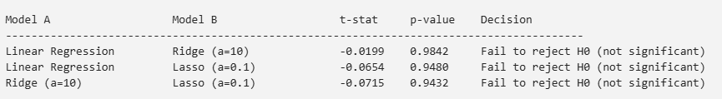
Figure 18: Paired t-Test: Model Comparison
All p-values > 0.05. No statistically significant difference between any model pair. This is expected with only 72 test observations (statistical power is insufficient to detect small differences). Ridge remains preferred on theoretical grounds (handles multicollinearity via L2) and empirical grounds (lowest CV RMSE).

    - Shapiro-Wilk Test: Residual Normality
H0: Residuals are normally distributed
H1: Residuals are NOT normally distributed
W=0.9520, p=0.0080 -> Reject H0 (residuals not normal) (p < 0.05)
With 72 observations, Shapiro-Wilk is highly sensitive to minor deviations. Log transformation already reduced skewness from 0.82 to -0.06. Ridge is more robust to residual non-normality than Linear Regression.

  - Feature Importance
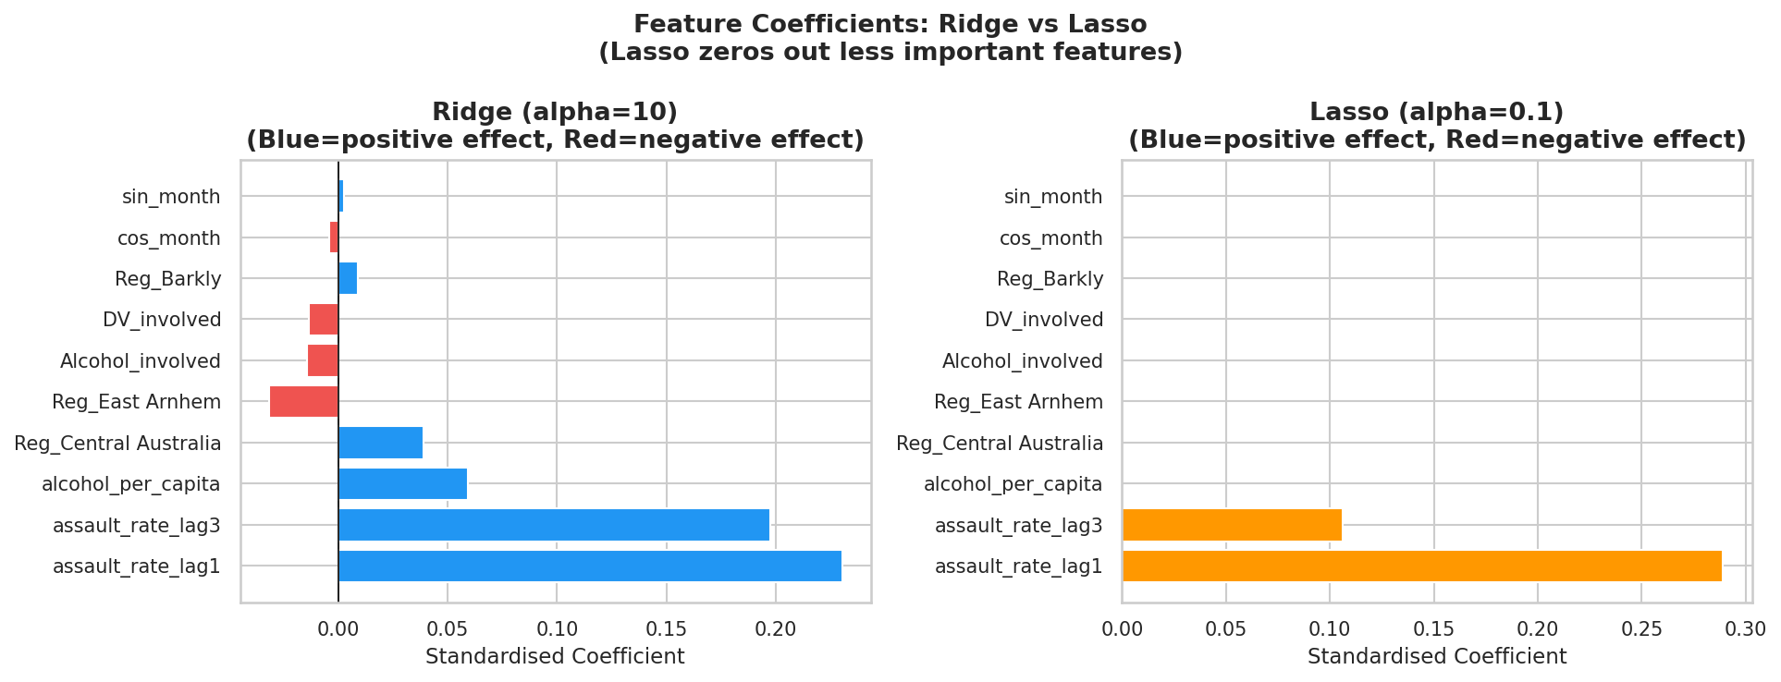
Figure 19: Feature Coefficients: Ridge vs Lasso
The coefficient comparison highlights the key difference between Ridge and Lasso regularisation. Ridge retains all predictors by shrinking them toward zero, preserving small but non-zero effects across the feature set. With the results produced by Ridge, we can see that lagged predictors have a huge influence on predictions along with the amount of alcohol consumed. In contrast, Lasso performs aggressive feature selection, zeroing out most weaker predictors and keeping only the strongest signals - primarily the lagged assault-rate variables. This demonstrates that while Ridge distributes influence across many features, Lasso identifies a sparse subset of dominant predictors, making it more suitable when interpretability and variable selection are priorities.

  - Monthly predictions for each region
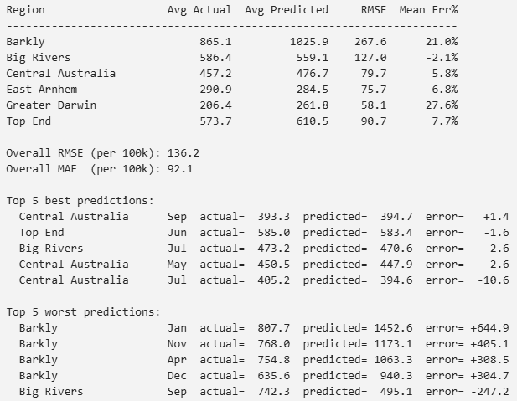
Figure 20: Predicted vs actual assault rate per region summary (2025)
The regional performance summary shows that the model performs well overall but exhibits substantial variation across regions. Central Australia, East Arnhem, and Big Rivers display relatively low RMSE and small mean percentage errors, indicating stable and reliable predictions in these areas. In contrast, Barkly and Greater Darwin show noticeably larger errors, with Barkly in particular experiencing severe over-predictions across multiple months. This pattern is reinforced by the worst-case examples, where Barkly dominates the largest errors, suggesting that the model struggles to capture volatility or unique local drivers in that region. Meanwhile, the best predictions cluster around Central Australia and Top End, indicating that the model generalises more effectively in regions with more stable historical patterns.
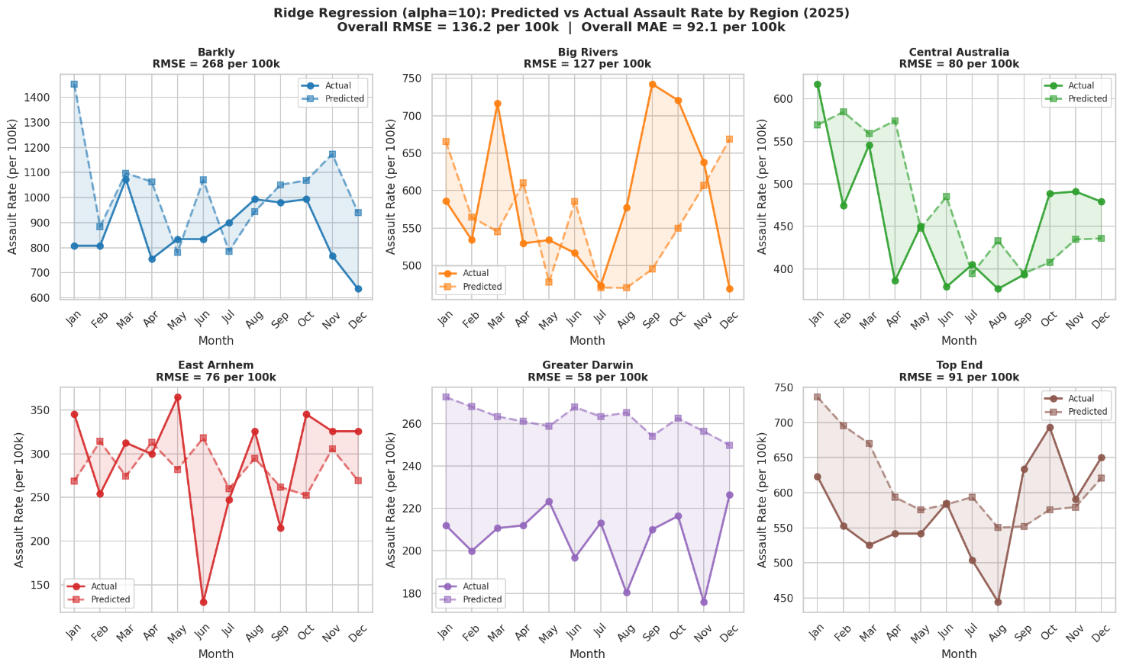
Figure 21:Predicted vs Actual Assault Rate by Region (2025)

- Conclusion
  - Answer to RQ1
January is consistently the month with the highest crime rate in the Northern Territory, with 6,168 total offences. This pattern holds across both 2024 and 2025 and is driven primarily by assault and theft. The seasonal spike aligns with the NT Wet Season (November-April), post-Christmas gatherings, and increased alcohol consumption during the holiday period.
  - Answer to RQ2
The short answer to this question is yes, as depicted above, we can use our regression models to predict crime rate (assault rate) for each region in the Northern Territory using past crime data (assault rate lags), population characteristics, as well as alcohol supply volumes. However, there is a disparity in the level of affection these explanatory variables have on the models. For example, as shown in the statistics above, the past crime rate has a far superior influence on the future crime rate than any other indicators.
Central Australia Sep and Top End Jun have the best predictions. However, Barkly Jan is the worst prediction, high month-to-month variance due to small population.

- Strengths and Limitations
  - Strength
As described in the statistics above, the Ridge Regression model demonstrates the strongest overall performance when used to predict crime rate. This is because the Ridge Regression model has a regularisation mechanism that helps to mitigate overfitting and multicollinearity by adding a penalty to regression coefficients and effectively shrinking them toward but not to zero (Montesinos-López et al., 2025). Linear Regression model, while having a higher error rate, still provides a strong baseline for model comparison. Lasso regression performance doesn’t have significant advantage over linear regression in this case, this can be attributed to the presence of high collinearity in the predictors, as suggested in research by Van Erp et al in 2019. This research advised that Lasso regression model’s performance suffers if the explanatory variables have a strong level of multicollinearity.
  - Limitations
- Small training set: 54 rows. Because NT Police switched to a new data collection mechanism called SerPro from December 2023 (iTnews, 2025), we only have data from 2024 to 2025. Moreover, as the data are time series, we decided to only train on the 2024 data and test on the 2025 data. This poses a huge limitation to our models, as the data points to train are limited in terms of quantity.
- Alcohol supply is a proxy: wholesales PAC tracks supply to retailers, not actual consumption.
- Report crim only: underreporting in remote regions means true rates may be higher.

References
Long, R. G. (2008). The Crux of the Method: Assumptions in Ordinary Least Squares and Logistic Regression. Psychological Reports, 103(2), 431–434. https://doi.org/10.2466/pr0.103.2.431-434
Poole, M. A., & O’Farrell, P. N. (1971). The Assumptions of the Linear Regression Model. Transactions of the Institute of British Geographers, 52(52), 145. https://doi.org/10.2307/621706
Northern Territory Police Force. (2025). Annual Report 2024-25.
https://hdl.handle.net/10070/1016397.
Australian Bureau of Statistics. (2025). Prisoners in Australia. ABS. https://www.abs.gov.au/statistics/people/crime-and-justice/prisoners-australia/latest-release.
Australian Bureau of Statistics. (2025, June). National, state and territory population. https://www.abs.gov.au/statistics/people/population/national-state-and-territory-population/latest-release.
Salvation Army Australia. (2025). Northern Territory social justice stocktake 2025.
https://www.salvationarmy.org.au/socialjusticestocktake/nt/
Wylie, B. (2025, March 20). NT tops offender rates, new crime stats reveal. @9News; 9News. https://www.9news.com.au/national/abs-crime-reports/1ef0321d-55f3-4bf8-8f24-1e94003ae8e7
Hathaway-Wilson, J. (2025, September 21). NT police data shows violent crime increasing, property crime decreasing. Abc.net.au; ABC News. https://www.abc.net.au/news/2025-09-22/is-nt-crime-decreasing-since-clp-government-elected-police-data/105797920
iTnews. (2025, August 3). How change management helped NT Police rescue delayed SerPro launch. ITnews. https://www.itnews.com.au/news/how-change-management-helped-nt-police-rescue-delayed-serpro-launch-619242
Montesinos-López, O. A., Barajas-Ramirez, E. A., Montesinos-López, A., Lecumberry, F., Fariello, M. I., Montesinos-López, J. C., Ramirez Alcaraz, J. M., Crossa, J., & Howard, R. (2025). Tuning Matters: Comparing Lambda Optimization Approaches for Ridge Regression in Genomic Prediction. Genes, 16(6), 618. https://doi.org/10.3390/genes16060618
van Erp, S., Oberski, D. L., & Mulder, J. (2019). Shrinkage priors for Bayesian penalized regression. Journal of Mathematical Psychology, 89, 31–50. https://doi.org/10.1016/j.jmp.2018.12.004

